[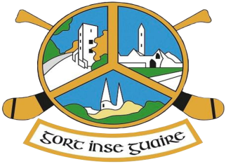](http://gortgaa.com/)

**Medical Guidelines**

**The information on this Medical Guidelines page is for information purposes only and should not be used as a definitive guide. Always check with a medical professional at all times if you have any questions relating to Medical needs.**

**Summary principles of GAA concussion management guidelines:**  
– Concussion is a brain injury that needs to be taken seriously to protect the long term welfare of all players.  
– Any player suspected of having sustained a concussion, should be removed immediately from the field and should not return to play on the same day.  
– Where a Team Doctor is present, he must advise the person in charge of the team (i.e. Team Manager) in this regard and the player must not be allowed to continue his participation in the game.  
– Concussion is an evolving injury. It is important to monitor the player after the injury for progressive deterioration.  
– Concussion diagnosis is a clinical judgment.  
– Players suspected of having a concussion must have adequate rest of at least 24 hours and then must follow a gradual return to play protocol.  
– Players must receive medical clearance (by a doctor) before returning to play.

**Signs and Symptoms**  
Contrary to popular belief, most concussion injuries occur without a loss of consciousness and so it is important to recognize the other signs and symptoms of concussion. Symptoms include:  
– Headache, Confusion, Nausea, Balance problems or dizziness, Double/blurry vision, Sensitivity to light, Feeling sluggish, hazy or groggy and concentration/memory problems.

**Return to play following all injuries/illnesses**

– Returning to play from a long illness, medical or surgical procedure requires a fit to resume certificate from a doctor or a note signed and dated by a parent stating the child is fit to resume to full sports participation.   
– A player with a diagnosed concussion should never be allowed to return to play on the day of injury.  
– Return to play must follow a medically supervised stepwise approach and a player should never return to play while symptomatic.

– Return after following Return to Play Protocol and getting medical clearance.